WHAT MOTIVATES TEACHERS TO DEVELOP CRITICALLY INFORMED CITIZENS IN THE MATHEMATICS CLASSROOM?
Suman Ghosh
UCL (Institute of Education), UK
suman.ghosh@ucl.ac.uk

ABSTRACT

The study outlines what motivates some secondary mathematics teachers to develop critically informed citizens in the mathematics classroom. Data was collected through eight semi-structured interviews which outlined the teachers’ own experiences and pedagogical approaches relating to developing students as critically informed citizens in the secondary mathematics classroom. An adapted version of Ernest’s model of mathematics-related belief systems was used as card sort prompts for the interview. The same model was also used to analyse the interview data and identify what motivated teachers to take this pedagogical approach. Evidence from the study suggests that teachers from diverse mathematical beliefs and academic backgrounds are motivated to develop students into informed citizens in the mathematics classroom because they have an underlying concern for the student. This underlying concern is not necessarily reflected in the teacher’s mathematical belief system.

Keywords: Critical Mathematics, Teachers’ Beliefs, Critically Informed Citizens,

1. Introduction
In exploring what motivates some secondary mathematics teachers to develop critically informed citizens in the mathematics classroom, the study situates itself in the broader concept of Critical Mathematics Education. In doing so, the study challenges the assumption that mathematics is a neutral discipline isolated from social life and politics. It argues that a socio-political perspective is an element of teaching and learning mathematics in order for it to contribute to social justice and democracy (Ernest and Sriraman, 2016).

Frankenstein (1983) emphasises the importance of developing critically informed citizens in the mathematics classroom, arguing that mathematical literacy is essential to work towards social change in an advanced technological society. Frankenstein approaches ‘mathematical literacy’ through the re-invention of Paulo Freire’s (1968) critical education theory in the context of a mathematics curriculum. Frankenstein (1983) gives an example of how mathematical illiteracy can lead people to believe that their declining standard of living is due to social welfare programmes when tax loopholes for rich taxpayers are not researched or criticised in the same way. Tutak et al (2011) explains how mathematical literacy is critical in order to reflect on the ways in which numbers dominate and liberate. This relates to Freire’s works (Freire, 1968), which stress that critical literacy requires reading the word and the world simultaneously. In both cases rather than processing texts or numbers there should be, as far as possible, an interpretation of social issues affecting the student. Similarly, Bartell (2013) explains that teaching mathematics for social justice provides students with the mathematics which is considered to be necessary to succeed in the current system, equipping them with the mathematical knowledge for confronting economic, political and social obstacles to their success.

Historically mainstream mathematics education does not have a tradition of critically examining connections between mathematics as an area of study and its relation to unequal economic, political and cultural power (Apple, 2000). Indeed, while critical mathematics education is often theorised, this rarely transfers to the chalkface (Ernest, 2016). Although there is certainly potential for mathematics to develop informed citizens, there is little research that examines mathematics teachers learning to teach for social justice. There is a significant amount of research relating to teachers in other disciplines learning to teach such issues (Bartell, 2013). This is reflected further in the findings of Robbins et al (2003) where they concluded that trainee mathematics teachers, when compared to teachers of eleven other secondary subjects, had the least positive attitude towards education for global citizenship. In relation to particular issues, such as sustainability, Barwell (2013, p6) explains that although ‘the role of mathematics in describing, predicting and communicating climate change does connect indirectly with many areas of research in mathematics education, so far there has not been any research that addresses how mathematics teaching might contribute to climate change education’.

Although there may be many arguments put forward for teaching mathematics and the type of knowledge that should be in the mathematics curriculum, Venkat (2014) directs these into two broader arguments that can be seen to lie at the centre of a debate. One argument is that mathematics teaching lays the foundations for the future learning of mathematics, such as post compulsory mathematics. Another argument is that it provides the skills which allow people to on a daily engage in a world in which they are exposed to quantitative data basis. For Venkat (2014) the second argument leads to mathematically literate people who are equipped to engage with the quantitative claims and the mathematics in everyday life. In order for students to be mathematically literate Venkat (2014) proposes that the mathematics teacher should provide opportunities in the classroom by drawing on issues in everyday life and adapting them into tasks for the mathematics classroom. Both arguments are valid and not mutually exclusive. However, the second argument might be side-lined because the pressure to perform well in exams may force schools to disregard broader moral, social and cultural issues in education (RSA - Schools with Soul Report, 2014).

With regard to research literature, the area of critical mathematics is well addressed in mathematics education. As well as a theoretical perspective, there are also publications that focus on how these ideas can be used in the classroom. Gutstein and Peterson (2005) provide examples of how to teach mathematics in a way that relates to the students’ lives and surroundings; it ‘rethinks’ classroom mathematics by threading social justice issues throughout the mathematics curriculum including ideas for cross-curricular mathematics. Similarly, Coles et al (2013), discuss a wide range of global issues which can be explored within different areas of the mathematics curriculum. However, even with these ideas and with related research literature, a tradition of critical mathematics education seems absent from the classroom. Apple (2006) identifies that where there have been gains, the materials do not relate to the daily realities of teachers’ and students’ lives.

Whereas there are clear arguments centred around mathematics and its role in developing critical citizens, there are identifiable barriers as to why this pedagogic approach does not transfer to the classroom.

2. Barriers
The view that mathematics is a ‘value free subject’ can be widespread in institutions and thus become detrimental to teachers wishing to develop critically informed citizens in the mathematics classroom. For example, Anderson and Valero (2016) report on a school-based project, ‘The Newspaper Flyer Workshop’, in which students were given the task of working in small groups to create flyers which have mathematical content in order to engage people with one of the 54 articles in the United Nations ‘Conventions on the Rights of the Child’. The context was a two week ‘Human Rights’ cross subject project in the school. However, the mathematics department had not been invited to be part of this project. The mathematics teacher felt that this marginalisation of mathematics sent the students a message that mathematics has no relation to other subjects or, indeed, the outside world.

A further challenge is posed by potentially interfering factors. In England, it is difficult to discuss classroom practice without reference to the curriculum and the related high stakes external assessment regime. In particular, there is a strong focus on Mathematics and English in the evaluation of schools (Brown, 2014). These factors influence the expectations and philosophy of a school, and there is a competitive pressure to teach to the test. These practical constraints make it difficult for teachers to work within the framework of their own pedagogical intentions (Ernest, 1991a).

3. Researching Teachers’ Mathematical beliefs
According to Pajares (1992), teachers’ judgements and perceptions are influenced by their beliefs, and these affect their behaviour in the classroom. An understanding of the beliefs of the teachers in this study may provide an insight into what motivates some teachers to develop critically informed citizens in their mathematics lessons. Historically, the idea of ‘beliefs’ is not generally addressed in educational research, as it does not present obvious opportunities for empirical investigation. Further, in order to understand beliefs we must appreciate their situated nature; in other words, certain beliefs may only apply to particular situations and so there may be contradictions in teachers’ beliefs (Swan, 2006).

As this study explored values teaching in the context of mathematics, it was important to make an explicit link between values and beliefs. Bishop (2010) identifies that in order to deal with issues of democracy in mathematics education, there is clearly a requirement to engage with values. However, Bishop (2010) identifies this to be problematic, since, unlike teachers of humanities and arts subjects, where the discussion and development of values seem relatively easy, most mathematics teachers would not consider teaching values when they are teaching mathematics. Indeed, teaching explicitly about values in the mathematics classroom is rare, as there is a widespread belief that mathematics is a value-free subject.

In researching teachers’ beliefs, Swan (2006) developed a set of teachers’ characterisations based on descriptions from Ernest (1991a) and Askew et al (1997). In explaining the differences between mathematics teachers, Ernest (1991a) suggests that while knowledge is an important factor, there needs to be an emphasis on teachers’ beliefs. These beliefs concern the teachers’ conception of the nature of mathematics. Ernest categorises these beliefs into three broad components:

1. View or conception of the nature of mathematics
2. Model or view of the of the nature of mathematics teaching
3. Model or view of the process of learning mathematics

These components form the basis of a teacher’s beliefs, or philosophy, of mathematics education. Ernest (1991a) broadly classifies these philosophies as: Instrumentalist, where mathematics is seen as a set of facts and rules; Platonist, in which mathematics is discovered and not created; and, thirdly, a problem solving and enquiry based approach to mathematics. Askew’s model (1997) characterises teachers’ conceptions of the teaching and learning of mathematics through three factors:

1. Transmission
2. Discovery
3. Connectionist

These three factors are similar to the components which form the basis of Ernest’s classification of teachers’ beliefs. The ‘transmission’ approach views mathematics as a subject with ‘rules and truths’ which are communicated through teacher led classrooms and individual practice. In the ‘discovery’ approach, the teacher takes the role of a facilitator and encourages students to learn through individual exploration. Finally, the ‘connectionist’ approach sees students working in collaboration, viewing mathematics as a network of ideas where the teacher has a role in challenging the students.

Further categories of students’ conception of mathematics were developed by Crawford et al (1994, p355) for their ‘conceptions of mathematics questionnaire’ which was used in an ongoing study of student learning in a first-year mathematics course. The study identified the qualitative variation of the conceptions, based on the question: ‘Think about the mathematics you have done so far. What do you think mathematics is?’. The conceptions related to the nature of mathematics rather than the process of learning mathematics.

The categories of beliefs identified or used by Askew, Ernest and Crawford clearly evidence that the beliefs in mathematics education are extensive (Handal, 2003), and in their extremes can be seen as two epistemological perspectives; the ‘absolutist’ view and the ‘fallibilist’ view. As teachers’ beliefs were central to this study, it was important to identify how these two epistemological perspectives relate to classroom practice. Ernest (1991a) describes the absolutist view of mathematics as an incorrigible, objective and certain body of knowledge resting on foundations of deductive logic. The absolutist philosophy of mathematics includes the schools of Platonism, Logicism, Intitutionism and Formalism. According to the absolutist view of Mathematics, all mathematical knowledge consists of unchallengeable truths (Ernest,1991a). Absolutist mathematics, therefore, is based on the idea of a fixed and certain knowledge that is absolute, objective and rational. Absolutism can take different forms, Lerman (1990) gives examples such as the embedding of mathematics within logic and the construction of mathematics from the basic intuition of time and the natural numbers.

Alternative to the absolutist view is the fallibilist philosophy which views mathematics as a creative human endeavour which is growing, changing and fallible. As such, Lerman (1994) suggests that mathematics education should empower students to question and criticise. In order for this to happen, students should be given the independence to develop skills such as proposing their own ideas, developing their own methods and testing their hypotheses (Lerman, 1983). This problem-posing approach to education regards dialogue as important in the act of cognition, making students critical thinkers. Central to problem posing education is the change in the relationship between the student and the teacher. The teacher no longer teaches from a point of authority relating to a knowledge base, but rather becomes a participant in the dialogue with the students. The classroom can become a place where children are relaxed and mathematical conversations can take place. Taking a fallibilist approach, the teacher can encourage the students, and indeed other students, to test their answers and ideas with other examples and counter examples.

However, Ernest (2007) emphasises that many mathematicians are attracted to mathematics for its absolutist features and, therefore, it would be wrong to see this approach as inappropriate. Indeed, a teacher could hold an absolutist view of mathematics but realise that it is necessary to adopt a fallibilist approach in the classroom. Skemp (1978), too, discusses the possible reasons as to why a teacher might adopt a ‘rules without reason’ approach. Skemp discusses mathematical understanding as ‘relational’ and ‘instrumental’. Similar to the absolutist and fallibilist approach, ‘relational understanding’ is knowing both what to do and why, whereas ‘instrumental’ understanding is ‘rules without reasons’. As Skemp identified that so many teachers teach instrumental mathematics he, playing devil’s advocate, discussed the advantages of an ‘instrumental’ approach to teaching mathematics. He explained that instrumental mathematics is usually easier to understand, and the rewards can be more immediate. For example, where children lack confidence in the subject, instrumental mathematics can help restore self-confidence more quickly. Further, less knowledge may be involved in achieving the answer more quickly instrumentally.

Another point to consider when we discuss teachers’ beliefs is the possible conflict between beliefs and practice. When facing certain restrictions, teachers are often compelled to shift their practice away from their beliefs (Ernest, 1991a). Swan (2006) also reveals that there are inconsistencies between a teacher’s beliefs and practices. For example, although there were teachers in his study whose belief was that mathematics is a creative subject where students can create their own concepts and methods, they reported that their practice only had occasional examples of this. For the most part, teachers felt that they were prevented from teaching in their preferred styles because of external factors such as the perceived need to cover the syllabus and a lack of resources. Skemp (1978) also highlights situational factors, such as the backwash effect of examinations and an over-burdened syllabus, leading to the absence of relational understanding. There is also an underlying implication that approaches such as ‘relational’ and ‘discovery’ allow for more creativity and questioning in mathematics, and so teachers who have these beliefs are more likely to include critical mathematics into their lessons. The beliefs mentioned here are often perceived to be polarised approaches in the classroom but should not be seen as entirely separate (Skemp, 1978). Further, Thompson (1992) asserts that individual mathematics teachers may identify with several aspects of these beliefs to varying degrees.

4. Methodology
The study explored how teachers with different beliefs develop critically informed citizens in the classroom. This was a case study research through the exploration of eight cases.
In order to minimise researcher intervention the study took an exploratory approach to interviews, where participants were initially prompted by a card sort activity. Participants who had shown an interest in developing critically informed citizens in their mathematics classroom were then observed teaching a timetabled lesson.

The following methods of data collection were used in the study:

- 8 semi-structured interviews of an exploratory nature. The purpose of the interviews was to determine the teachers’ own experiences and pedagogical approaches relating to developing critically aware citizens in the secondary mathematics classroom. The interviews were prompted by a card sort exercise, which outlined different mathematical related belief systems, such as authoritarian, progressive or socially aware (Ernest, 1991b).
- Observations of a small sample of eight mathematics teachers who took approaches to develop critically aware citizens in their lessons. The focus of the observations was how the teacher could develop critically aware citizens within the context of the mathematical content of the lesson. Teachers were also asked for written reflections of the lesson they taught.
- Only the data from the interviews and the teacher reflections were used in this paper.

Handal (2003, p47) identifies that ‘the range of teachers’ mathematical beliefs is vast since a list would include all teachers’ thoughts on personal efficacy, computer, calculators, assessment, group work, perceptions of school culture, particular instructional strategies, textbooks, students’ characteristics and attributional theory, among others.’ In the previous section it was discussed how Ernest categorises beliefs into three broad components (view or conception of the nature of mathematics, model or view of the of the nature of mathematics teaching, and model or view of the process of learning mathematics). Ernest (1991a) uses these components to develop an overview and a comparison of different groups and five overarching ideologies. The beliefs of the five different social groups (Industrial Trainer, Technological Pragmatist, Old Humanist, Progressive Educator and Public Educator) are compared across the following ideologies:
Political Ideology, View of Mathematics, Moral Values, Theory of Society, Theory of the Child, Theory of Ability, Mathematical Aims, Theory of Learning, Theory of Teaching Mathematics, Theory of Resources, Theory of Assessment in Mathematics, Theory of Social Diversity.
Ernest recognises that this model is somewhat superficial, though it serves an orientating function. He presents a simplified version of this model (Ernest, 1991b, p61) which assumes that a deep-seated ideology, comprising of intellectual and ethical theories, lies at the heart of any teacher’s belief system (Ernest, 1991b). In this model, Ernest outlined a more refined grouping of five different mathematics related belief systems which he infers can be found amongst teachers (Table 1). The model can be used as an empirical research instrument for assessing teachers’ beliefs and as a stimulus for reflection (Ernest, 1991b).

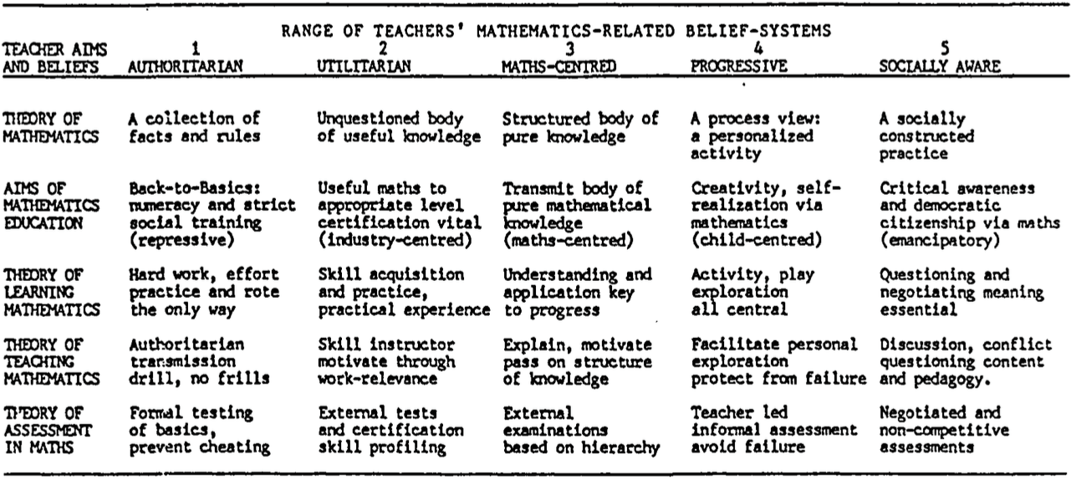

Table 1: Table of teachers' beliefs

However, according to Ernest (1991b), the model is intended to exemplify a development of quality from position 1 to 5, so associating ‘quality’ with a constructivist approach.

In considering Ernest’s model it is acknowledged that he recognises that the model makes many assumptions and will be seen as too simplistic. However, the model is theoretically well grounded and offers appropriate prompts for more detailed discussions in an interview about mathematical beliefs. Whereas Ernest has introduced his position of ‘quality’ into the model, the model was adapted for the study by eliminating the progressive nature of the original table and
rearranging the model as in so that participants were not influenced by the implication of ‘quality’ (Table 2).
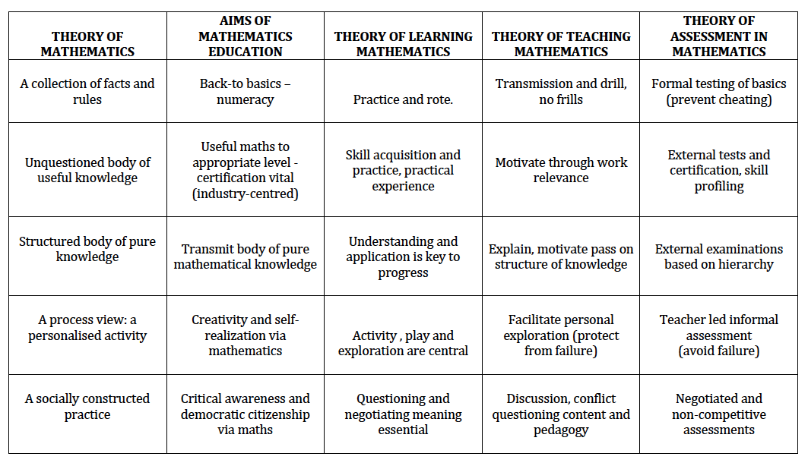

Table 2 : Adapted version of 'Range of teachers' beliefs
The statements were then transferred onto individual cards in order that they can be used to prompt discussions throughout the interview (Figure 1).

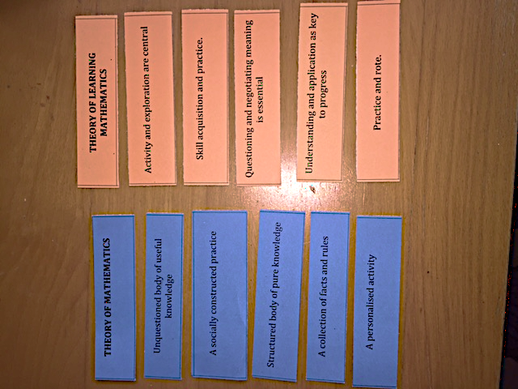
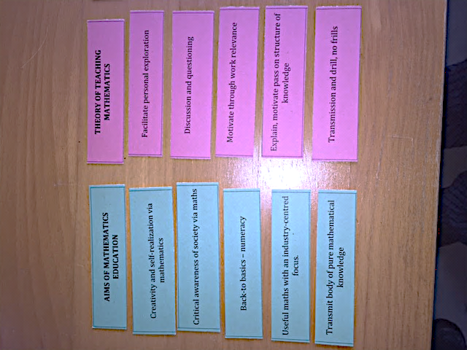

Figure 1: Card sort

The cards were set out in piles, under their title and they were organised randomly. Following feedback from the pilot study, the cards relating to ‘Theory of Assessment in Mathematics’ were removed for the final card sort.

Dowling and Brown (2010) advise that the use of prompts involve suggesting possible responses and thus interrupt the spontaneity of the interview; however, this does mean not that they should be avoided and, for particular types of interviews, they may be crucial. They explain that interviewees can find abstract questions difficult to comprehend, particularly if these have not been given any prior thought, hence they suggest that ‘it is essential to provide the interviewee with initial stimuli – questions or activities – with which they can easily engage’ (Dowling and Brown, 2010, p81). For this reason, the use of prompts was appropriate as part of the interview. Further, as some of the participants have degrees in disciplines other than mathematics it might have been more difficult for them to articulate their mathematical beliefs in response to an open question. Therefore, the statements of teachers’ beliefs were presented as a set of cards (Figure 1); the cards were classified according to Ernest’s categories. The cards in each category (Theory of Mathematics, Aims of Mathematics Education, Theory of Learning Mathematics, Theory of Teaching Mathematics and Theory of Assessment in Mathematics) were a different colour. For example, all the Theory of Learning Mathematics cards were orange, so these would be easier to identify for both the participants the researcher. Participants had to choose the cards which reflected their belief system. Participants could choose more than one card from each category and place them in order of importance, or they did not have to choose any cards and could discuss why they felt they did not agree with any of the statements on the cards. It was important that all prompts were used in a consistent way with all interviewees (Robson, 2002). The interview was to be prompted by the responses from the card sort activity and by asking participants the reasons behind their decisions; however, in order to achieve more in-depth responses, further questions were supplemented into the interview where appropriate.

5. Observations
The study also required data on the type of lessons the participants were teaching. Data could have been collected by asking the participants for their lesson plans and a discussion about the lesson. However, teachers may not be accurate when reporting on their own practice, as they may be influenced by the objectives of the study or may conform to the norm of the school (Basit, 2010). Therefore, an observation of the participant teaching a lesson proved to be a suitable source of data in a naturally occurring, uncontrived setting. Observations of the lessons took place in school while the participant was teaching a timetabled lesson.

6. Findings

6.1 What motivates some secondary mathematics teachers to develop critically informed citizens in the mathematics classroom?
Ernest recognises that it is common for teachers to combine positions when using his model of Mathematics-Related Belief Systems. Therefore, when analysing interview and card sort data, it is not surprising that the teachers in the study had identified with beliefs across the five belief systems. However, in all cases the summary of participant’s beliefs tended to prioritise a particular belief system and, in some cases, there were some belief systems which, even if they were not prioritised, were certainly prevalent. Further, beliefs were not necessarily consistent, as we know that particular beliefs may only apply to certain situations (Swan, 2006). For example, Jason, a history graduate who taught in an academy school, mentioned that his opinion is different for different classes. He used his lower set Year 11 class as an example of how his beliefs could be different for a class with different aspirations, where there is an element of ‘hoop jumping’ to get the required qualifications. However, these beliefs were limited to particular situations and classes and did not influence the predominant mathematical beliefs of the participants.

As critical mathematics and social justice are associated with questioning, discussion and personal exploration, we could be led to believe that all teachers who aim to develop critical citizens in their lesson would have ‘progressive’ and ‘socially aware’ beliefs prioritised within their belief system. However, only one participant, Fabia, a classics graduate who taught mathematics and some Latin in an girls Roman Catholic Convent School in inner London, had prioritised the socially aware approach in her belief system:

‘If we are talking about the broad overall aims of mathematics education, this should be more about the discovery of mathematics and how that helps them live in the real world. That does not mean that they have to do mathematics that is directly associated with an industry, but that they can apply it to being a scientist or being a statistician, but also they can use their mind and the skill that they gain from mathematics to assess and to live well in the real world’
Fabia (Interview, 30.4.15)

Six of the eight teachers in the study prioritised beliefs other than ‘socially aware’ or ‘progressive’, suggesting that teachers with these beliefs can still have some type of commitment to developing critically informed citizens in the mathematics classroom in their lesson. For example, Aron, a mathematics graduate who taught the subject in a large mixed gender secondary comprehensive school situated in North London, identified ‘critical awareness of society via mathematics’ as a low priority in his beliefs:

‘Critical awareness of society via mathematics – I don’t know if that is what I would do in my mathematics education. I think that other subjects should speak numeracy, should speak number and that is where that would form, I don’t think there is time unless you gave mathematics teachers far more time in class to be able to do this’
Aron (Interview, 7.5.15)
Rachel, a mathematics graduate who taught the subject in a mixed secondary school in East London, also placed ‘critical awareness of society via mathematics’ low down in her belief system, identifying much more with the absolutist beliefs relating to mathematics education:

‘"Unquestioned body of useful knowledge", that's an interesting choice of words. I suppose because Math is very absolute, is very axiomatic, once it is true, it is always true. Supposing that sense is unquestioned. There's nothing in there about linking things together, because I think that's one of the most exciting things about Math. Yes, it is a collection of actual facts and rules, but actually they will relate to each other. Actually, yes, it is facts and rules, but actually it's also, how do you apply those and how do they all relate to each other. It's the relationships I think, the most exciting things’
Rachel (Interview, 8.12.15).

In the case of Santana, a Politics and International Relations graduate who taught in an academy school, although prioritising ‘mathematics centred’ and ’authoritarian’ beliefs, her lesson involved students participating in decision making mathematics throughout the lesson, deciding how money from taxes should be distributed by the government and drawing pie charts to represent their ideas, so positioning the lesson firmly within an investigational landscape with reference to real life. She also mentioned how she planned to compare GDP, wealth and poverty figures across different countries, in a future lesson.

Therefore, there was no theme arising with regard to the predominant belief systems of the participants and why they decided that developing critically informed citizens in their mathematics lesson was important. However, developing critically informed citizens was not for done the sake of the study, as other similar lessons had been planned or had been taught by the participants. There also seemed to be underlying reasons as to why the teachers had decided to take this pedagogical approach. This was related to something they felt, as teachers, was important for their students. Although not completely unrelated to beliefs, it was evident from the interviews that the teachers felt they had an underlying responsibility to prepare students for the real world.

6.2 What other underlying reasons were there as to why some secondary mathematics teachers develop critically informed citizens in the mathematics classroom?

Most of the participants did not prioritise ‘socially aware’ or ‘progressive’ beliefs, but, as mentioned in the previous section, they were all committed to developing critically informed citizens in the mathematics classroom in their lesson, albeit to different degrees. As well as their beliefs, there were underlying reasons as to why some participants decided to take this pedagogical approach.

Rachel’s mathematical beliefs were predominantly ‘mathematics-centred’ with some elements of ‘authoritarian’. However, she still felt that it was important for her students to be aware of how graphs or statistics in the media could be manipulated to misinform people.

‘I wanted students to be able to spot when graphs or statistics in newspapers, and other media, are manipulated to support statements which aren't necessarily true’.
Rachel (Interview, 8.12.15)

Aron prioritised ‘utilitarian’ beliefs. With regard to critical mathematics, he remarked: ‘I don’t know if that is what I would do in my mathematics education’. However, he taught a lesson on compound interest in which he identified that it was a priority that students were mathematically literate:

‘I want kids to know which mortgage is best for them, I want kids to know how many litres of paint they need to paint their house and figure out that kind of stuff, and that’s not necessarily the focus of education as it currently stands……. I think that it is a priority is that kids are mathematically literate. Pupils aren’t taught about taxes, pupils aren’t taught about retirement or interest rates. There’s no class for that and the incentives aren’t there for the mathematics departments to teach that, but there should be, because we are sending pupils out into the world, not teaching them how to figure out ‘if I got a 1200% APR what am I going to pay next month?’, and that’s ridiculous. And a lot of pupils in the demographics of this school will be going for a payday loan or pawning something or taking a job and not realising how little they will be paid’.

Aron (Interview, 7.5.15)

Fabia had prioritised the ‘socially aware’ and ‘progressive’ approaches as part of her belief system. Beyond this, she had concerns about her pupils and their knowledge of real word issues such as elections and the voting system:

‘Pupils’ prior knowledge of politics in the UK was not strong, and so I had to adapt to make sure that pupils understood all the key terms. In particular, they found it difficult to grasp what a constituency and a seat were’.
Fabia (Interview, 18.12.15)

Jason prioritised the ‘mathematics-centred’ beliefs and was critical of constructivist approaches in teaching mathematics. However, he had been teaching in the school for three years and seemed to be in agreement with the school ethos with regard to improving pupils’ aspirations through their academic development. Having taught a lesson on relating to NHS funding, he reflected that:

‘What I thought was particularly beneficial was how the relevance would increase their aspirations. This is something that I will be able to refer back to in future lessons’.
Jason (Interview, 27.4.15)

The interviews imply that it is the teacher’s underlying concern for their students, and not necessarily the teacher’s mathematical beliefs, which is the motivation for developing critically informed citizens in the mathematics classroom. As a practitioner-researcher, Gutstein (2003) expresses similar underlying beliefs when he describes his larger goals as a teacher. As a mathematics teacher, Gutstein (2003) explains that, in addition to his mathematics-specific objectives, he identified larger goals such as helping develop the students’ social and political consciousness, sense of agency and social and cultural identities. The case studies in this research reveal that, beyond their mathematical beliefs, teachers are motivated to develop critically informed citizens in their lesson as they have an underlying concern for students to have a critical awareness of the world through mathematics. Situating concepts of critical mathematics and social justice in the mathematics classroom is a pedagogical approach which can be practised by teachers from wide ranging mathematical beliefs. At a time when children are surrounded quantitative data relating to major issues such as covid, elections and global warming, it is important that teachers develop students to become mathematically literate and critically understand their world.

References

Anderson, A. & Valero, P. (2016). Negotiating critical Pedagogical Discourses: Stories of
Contexts Mathematics and Agency. In P. Ernest, B. Sriraman & N.Ernest (Eds.)
Critical Mathematics Education: Theory, Praxis, and Reality. Charlotte, NC: Information Age.

Apple, M. (2000). Mathematics reform through conservative modernization?
Standards, markets and inequality in education. In J. Boaler (Ed.) Multiple perspectives on mathematics teaching and learning, (pp. 243-259) Westport, CT: Ablex.

Apple, M. (2006). Series editor's introduction. In E. Gutstein, Reading and writing the world
with mathematics: Toward pedagogy for social justice, (pp. ix-xii) New York: Routledge.

Askew, M., Brown, M., Rhodes, V., Johnson, D. & Wiliam, D. (1997). Effective teachers of
numeracy, final report. London : Kings College

Bartell, T. (2013). ‘Learning to Teach Mathematics for Social Justice: Negotiating Social Justice
and Mathematical Goals’, Journal for Research in Mathematics Education, 44(1), 129-163.

Barwell, R. (2013). ‘The mathematical formatting of climate change: critical mathematics
Education and post-normal science’, Research in Mathematics Education, 15(1), 1-16.

Basit, T. (2010. Conducting Research in Educational Contexts, London: Continuum‬. ‬‬‬‬‬‬‬‬‬‬‬‬‬‬‬‬‬‬‬‬‬‬‬‬‬‬‬‬‬‬‬‬‬‬‬‬‬‬‬‬‬‬‬‬‬‬‬‬‬‬‬‬‬‬‬‬‬‬‬‬‬‬‬‬‬‬‬‬‬‬‬‬‬‬‬‬‬‬‬

Bassey, M. (1999). Case study research in educational settings, Buckingham, Philadelphia: OUP

Bishop, A. (2010). Mathematics Teaching and Values Education – An Intersection in Need of
Research. In P. Clarkson and N. Presmeg (Eds.) Critical Issues in Mathematics Education, (pp. 231-238) New York: Springer.

Brown, M. (2014). Debates in Mathematics Curriculum and Assessment. In D.Leslie and
H.Mendick (Eds.) Debates in Mathematics Education (pp. 151-162), Oxon: Routledge.

Coles, A., Barwell, R., Cotton, T., Winter J. & Brown, L. (2013). Teaching Secondary
Mathematics as if the Planet Matters, London: Routledge
Crawford, K., Gordon, S., Nicholas, J. & Prosser, M. (1994). Conceptions of mathematics and
how it is learned: The perspectives of students entering university, Learning and Instruction, Volume 4, Issue 4

Dowling, P. & Brown, A. (2010). Doing Research / Reading Research, Oxon: Routledge

Ernest, P. (1991a). The Philosophy of Mathematics Education,
London:Falmer Press.

Ernest, P. (1991b). ‘Mathematics teacher education and quality’, Assessment and Evaluation in
Higher Education, 16(1), 56–65.

Ernest, P. (2007). ‘Epistemology plus Values equals Classroom Image of Mathematics’, Keynote
Speech at Conference on Values in Mathematics and Science Education, 3-4 August 2007, University of Malaysia, Kuala Lumpur, Malaysia.

Ernest, P. (2016). The scope and limits of critical mathematics education. In P. Ernest,
B. Sriraman, & N. Ernest (Eds.) Critical mathematics education: Theory, praxis, and reality, (pp. 99 – 126) Charlotte, NC: Information Age.

Ernest, P. & Sriraman, B. (2016). Foreword. In P. Ernest, B. Sriraman, & N. Ernest (Eds.)
Critical mathematics education: Theory, praxis, and reality, (p. vii) Charlotte, NC: Information Age.

Frankenstein (1983). ‘Critical mathematics education: An application of Paulo Freire’s
Epistomology’ Journal of Education, 165(4), 315-339.

Freire, P. (1968). Pedagogy of the Oppressed, Reprint (2005), London: Continuum International Publishing2005.

Gutstein, E. (2003). ‘Teaching and Learning Mathematics for Social Justice in an Urban, Latino
School’, Journal for Research in Mathematics Education, 34(1), 37-73

Handal, B. (2003). ‘Teachers’ mathematical beliefs: A Review’, The Mathematics Educator,
13(2), 47-57.

Lerman, S. (1983). ‘Problem Solving or knowledge-centred: the influence of philosophy on
mathematics teaching’, International Journal of Mathematical Education in Science and Technology, 14(1), 59-66.

Lerman, S. (1990). ‘Alternative Perspectives of the Nature of Mathematics’, British Educational
Research Journal, 16(1), 53-61.

Lerman, S. (1994). Critical / humanistic mathematics education: A role for history?. In M.
Selinger (Ed.), Teaching Mathematics (pp. 97-102) London: Routledge.

Pajares, M. F. (1992). ‘Teachers' beliefs and educational research: Cleaning up a messy
construct’, Review of Educational Research, 62(3), 307–32.

Robbins, M., Francis, L. and Elliot, E. (2003). 'Attitude toward education for global citizenship
Among student teachers', Research in Education, 69, 93–98.

Robson, C. (2002). Real World Research, Oxford: Blackwell.

Royal Society for the encouragement of Arts, Manufactures and Commerce (2014) Schools with
Soul Report, Online at: https://www.thersa.org/discover/publications-and articles/reports/schools-with-soul-a-new-approach-to-spiritual-moral-social-and-cultural-education (Accessed October 2017).

Seah, W.T. (2010). Valuing Values in Mathematics Education. In P. Clarkson & N. Presmeg (Eds.) Critical Issues in Mathematics Education, pp. 239-252, New York:
Springer

Skemp, R. (1978). ‘Relational understanding and instrumental understanding’, Arithmetic
Teacher, 26(3), 9–15.
Skovsmose, O. (1990). ‘Mathematical Education and Democracy, Educational Studies in
Mathematics, 21 (2), ,pp. 109-128

Swan, M. (2006). ‘Designing and Using Research Instruments to Describe the Beliefs and
Practices of Mathematics Teachers’, Research in Education 75(1), 58-70.

Thompson, A. (1992). Teacher’s belief s and conceptions: A synthesis of the research. In D.A.
Grouws (Ed.) Handbook of research on mathematics teaching and learning (pp. 127- 146) New York: Macmillan

Tutak, F., Bondy, E. & Adams, T. (2011). ‘Critical pedagogy for critical mathematics education’,
Journal of Mathematical Education in Science and Technology, 42(1), 65-74.

Venkat, H. (2014). Mathematical Literacy. In D. Leslie & H. Mendick (Eds.) Debates in
Mathematics Education, (pp. 163-174) Oxon: Routledge

